Homework 4 Report - Group 7

Graham Flinchum, Leonardo Izzi, Sweta Rout

System Diagram

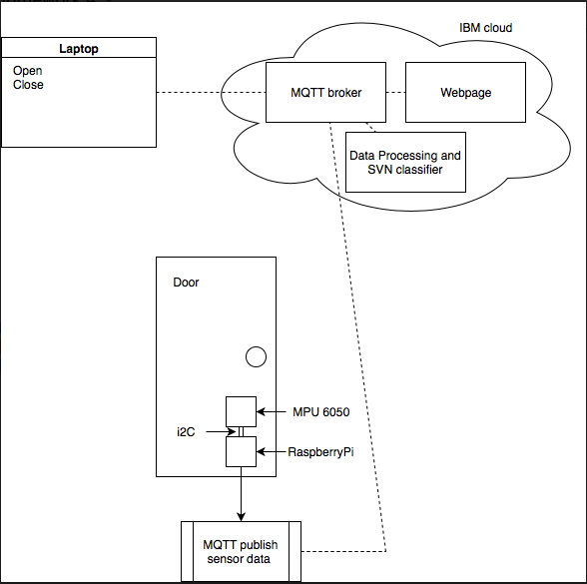

MPU6050 and Raspberry PI are attached to the door. An MQTT connection is established between raspberry pi and MQTT broker running on the IBM bluemix cloud. In the cloud is also a client that performs data processing on that data and determines when an event occurs, it also classifies the event. A webpage and a laptop are subscribers to the class type and will print to screen any events that take place.

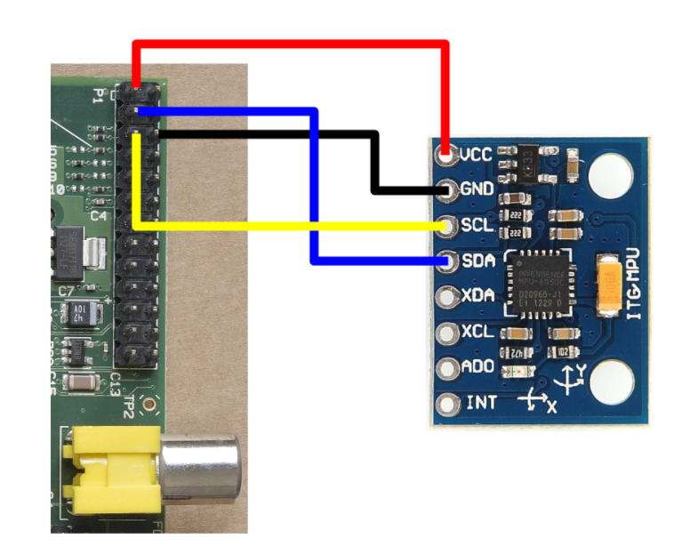

**Feature Extraction and Selection**

The MPU6050 was interfaced to the raspberry pi over an i2c interface (as shown in image above). Every 10ms the raspberry pi queries the MPU6050 for gyroscope and accelerometer data. It will then publish over MQTT. We chose qos of 0 because we wanted to have less latency and more data points. We also decided that we would only use the x acceleration axis with the MPU6050 placed in such a way that the x axis was perpendicular to the door. Therefore the door always moved along the x axis. We felt that we could distinguish between open and close by the direction of acceleration. A positive acceleration would indicate a door open, and the opposite a door close. The processing algorithm goes through a 100 sample calibration on start up, where it assumes the door is closed. This is to obtain a baseline average. 10 consecutive samples with a value of 4 standard deviations from the mean indicates that an event is starting. 10 consecutive samples with a value within the 4 standard deviations of the mean indicate that an event has ended. The event data is then broken up into an 5 evenly sized chunks. The average of each chunk become the data points for each sample of the training and test data.

**Classification Method**

To detect door event and close, we used SVM classifier. SVM builds a training model based on the training set to classify the test data. It tries to build classes as wide as possible. In our task, we have two class labels : Open and Close. Every data point is assigned a label. For classification, we have taken acceleration of the door as a feature.

Training Set

Training set is created by capturing 30 door events using MPU and Raspberry Pi. These are labelled as either Open or Close and saved in a csv file. This data is pushed to bluemix, and a classification model is created based on it.

Testing Set

The test data is captured by the RaspberryPi and MPU and sent to bluemix. Bluemix has a classifier running on it that classifies the test data based on the model and labels it as Open or Close.

Classification

To classify, SVM is used. Python libraries scikit-learn, scipy, numpy and sklearn are used to train the model. First the training set is passed to svm to fit the model and then test features are passed to predict the class label of the test data.

**Tasks**

Interfacing with MPU and extracting values - Leonardo

Data processing to determine event start and end - Leonardo

Data processing to break up data and simplify data points - Leonardo

Creating training data set - Graham

Sending values to the cloud - Sweta

Configuring Raspberry Pi to connect to Bluemix - Sweta

Data Classification - Sweta

Integrating all components and debugging - Graham/Sweta

Creating webpage to display values - Sweta

Adjusting sensitivity of data processing to prevent multiple event triggers - Graham

**Contribution**

Leonardo - 33.33

Sweta - 33.33

Graham - 33.33